|  |  |
| --- | --- |
|  | Student Name _______________________    **Eastern Goldfields College**  Mathematics Applications 2019  Test 4 (U2 T1) – Calculator Free1 |
| **Time allowed: 20 minutes** | **Total Marks: 26 marks** |

**No calculator or notes permitted for this section.**

***Answer all of the following questions. Show all working to obtain full marks.***

**Question 1 (2 marks: ½, ½, ½, ½)**

Use D for discrete or C for continuous to classify each of the following types of numerical data.

(a) The mass of the Year 11 Rugby Team.

(b) The speed of cars passing the front of the school.

(c) The number of baskets scored in a basketball game.

(d) The various sizes of the school jumpers in the uniform shop.

**Question 2 (3 marks: 1, 2)**

An isosceles triangle has a base of *x* + 11 cm and sides of *x* cm.

(i) Find an expression for the perimeter of the triangle.

(ii) If the perimeter of the triangle is 50cm, determine the value of *x*.

**Question 3** **(8 marks: 2, 2, 2, 2)**

Solve the following equations: (Show full algebraic working)



$2x-6 =14$

$3\left(6-2x\right)=28$

$\frac{3x}{10} = \frac{2}{5}$

$\frac{ 5}{x} =40$

**Question 4** **(6 marks: 2, 4)**

(a) The mean height of a sports team is 182 cm. One of the players who is 172 cm tall leaves the team. Will the mean height increase, decrease or remain the same. Justify your answer.

(b) The whole numbers below are arranged in **ascending** order and have a mean of 6.

1, 3, , 6, 7, , 9, 10

Determine **all** the possible values for  and .

**Question 5**  **( 3 marks: 2, 1)**

Lily and Tom planned to collect data on the number of hours that the 30 students in their Year 11 class spent watching TV on a weekday night.

|  |  |
| --- | --- |
| Time (Hours) | Tally |
| 0-1 |  |
| 1-2 |  |
| 2 or more |  |

Lily created the table as shown on the right and

planned to ask each student which group they

belonged to.

1. Describe one advantage and one disadvantage of her method.

Tom decided to ask each student and simply make a list of all their times.

1. Describe one advantage **OR** disadvantage of his method.

Question 6 (3 marks 1, 2)

(a) The equation  can be used to represent the statement that during a weekend when a cafe sold 87 muffins, the shop sold 23 more muffins on Saturday than on Sunday.

(i) Explain what the variable x represents.

(ii) How many muffins did the shop sell on Saturday?

**End of Non-Calculator Section**

|  |  |
| --- | --- |
|  | Student Name ________________________    **Eastern Goldfields College**  Mathematics Applications 2019  Test 4 (U2 T1) – Calculator Assumed  1 |
|  | **Time allowed: 35 minutes Total Marks: 32 marks** |

**Calculator and one A4 page of notes permitted for this section.**

**Question 7** **(5 marks: 2, 2, 1)**

Jeremy sells sausages in bread outside Bunnings on Sundays. The number of sales each day over 30 Sundays was recorded as follows:

66 64 28 93 47 110 53 68 117 43

72 68 84 103 59 82 78 61 104 79

51 63 112 81 79 94 42 57 83 100

1. Draw a stem-and-leaf plot to represent this data
2. On what percentage of days did Jeremy have more than 50 sales?
3. One day Jeremy only had 28 sales. Give one possible reason for this in relation to the scenario.

**Question 8** **(12 marks: 3, 1, 2, 2, 2, 2)**

The birth weights, in kilograms, of **12 baby girls** are listed in ascending order below:

2.95, 3.00, 3.03, 3.06, 3.07, 3.10, 3.15, 3.25, 3.29, 3.41, 3.45, 3.49

(a) For these 12 weights, determine

(i) the mean

(ii) the median

(b) Briefly explain why the mode is not a suitable measure for indicating central location for this data.

The histogram below shows the birth weights of **16 baby boys**.

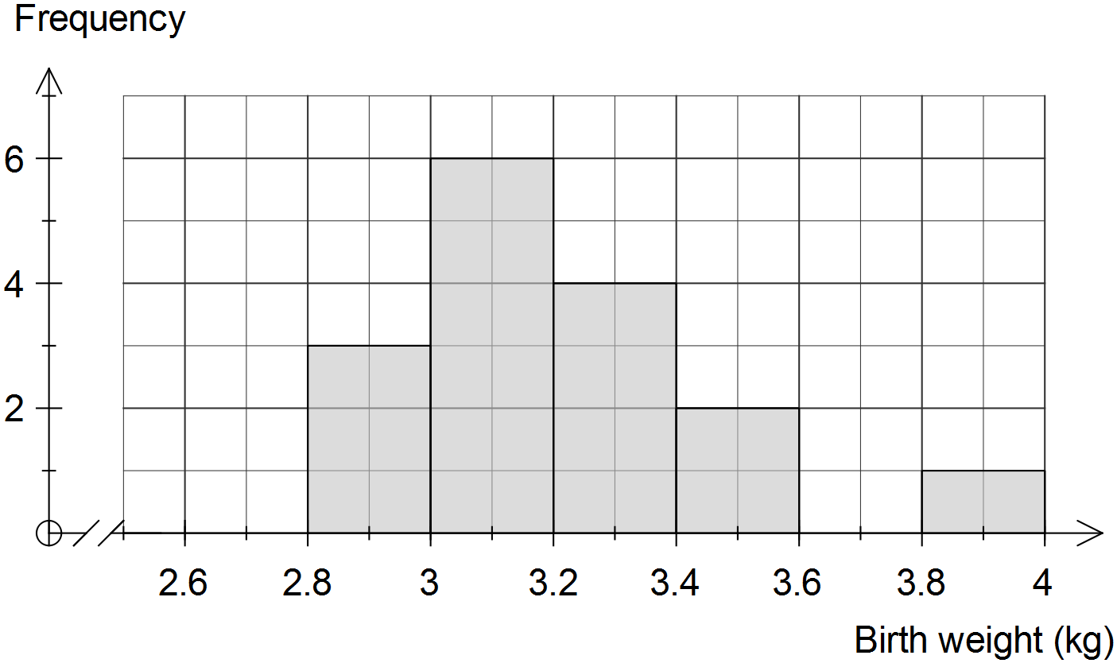

(c) Describe the distribution of the weights of the 16 baby boys.

(d) Use the information on the previous page to complete the frequency table below for the **combined weights** **of all** **28 babies**.

|  |  |
| --- | --- |
| Weight (kg) | Frequency |
|  |  |
|  | 5 |
|  |  |
|  |  |
|  |  |
|  |  |
|  |  |

(e) Estimate the mean weight of all 28 babies using the frequency table.

(f) Use the frequency table in (d) to construct a frequency histogram on the axes below.

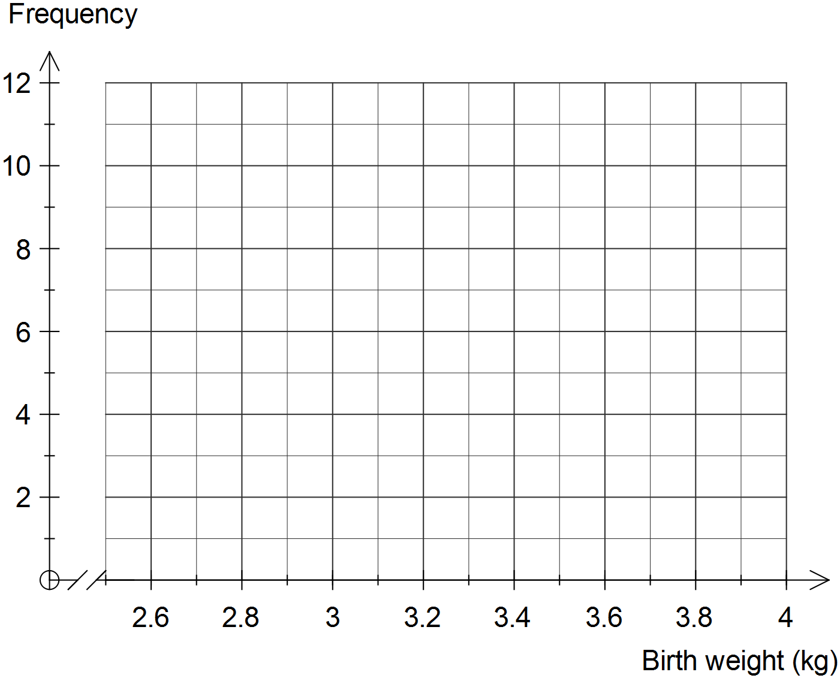

**Question 9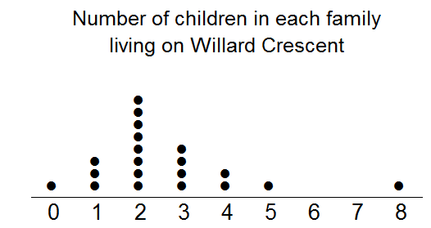 (8 marks: 1, 2, 1, 2, 2)**

This dot plot shows the number of children in each family living on Willard Crescent.

1. How many families live on Willard Crescent?
2. Calculate the mean number of children per family.
3. The family with 8 children is an outlier. Without re-calculating the mean, how is the mean affected if this outlier is removed from the data set?

1. Give two reasons why the mean is not a good measure of centre for this data.

1. An extra family moved into Willard Crescent, increasing the mean number of children to 3. Considering all the original data (including the outlier), how many children did the new family have?

**Question 10** **(2 marks)**

The mean of seven scores is 53. If six of the scores were 60, 50, 37, 60, 55 and 32, find the seventh score.

**Question 11 (5 marks)**

Two classes, class A and class B, sit the same test and the combined mean is 72%. Class A has 50 students in it and the class mean is 69%. Class B has a class mean of 78%. Determine the total number of students for class B. Ensure you show full algebraic working.

**End of Calculator Section**